IS201 Project Proposal
Airline Tickiting System

Table Of Contents
1.Introduction 2
The Proposed System 3
Objectives: 3
Problem Statement 4
Project Scope: 4
Constraints: 5
Assumptions 5
2.Literature Review 6
3.The proposed system design 7
4.Development……………………………………………………………………………………………………..8
4.1 Main page……………………………………………………………………………………………………….9
4.2 Available flights………………………………………………………………………………………………10
4.3 Select seats…………………………………………………………………………………………………..11
4.4 Flight Booking…………………………………………………………………………………………..11
4.5 Passengers Detail……………………………………………………………………………………..12
4.6 Fields Verification………………………………………………………………………………………12
4.7 Payment Methods……………………………………………………………………………………….13
4.8 Terms and Conditions…………………………………………………………………………………..13

5.References…………………………………………………………………………………………………………9

1.Introduction
Nowadays, traveling by plane is common for many people, but booking a ticket can sometimes be a long and hard process. In the past, passengers had to go to the airport or call an the staff to buy or cancel their tickets. This way took time and sometimes have a lot of mistakes.
Because of technology, everything became easier. The idea of this project is to make an E-Ticketing System for Airlines that helps passengers book tickets online in a simple way. The system will save time, less physical writing, and make it easy flight for both passengers and airline staff.

The Proposed System
The Airline Tickiting system is designed using Visual Studio ASP.NET web forms. It will have a homepage, menu, and site map. It focuses exclusively on the passenger or customer side of functionalities which are:
- Browsing flights based on distention and date.
- Booking a flight.
- Paying securely online.
- Checking-in and choosing a seat.
- Help center to clear any confusion or errors.

The system will use validation tools such as RequiredFieldValidator to ensure the accuracy of all information.
In the end, this system will make the ticket process faster, safer, and clearer for everyone.

Objectives:
- To create an online airline ticketing system that allows customers to search, book and manage flights from anywhere and at any time.
- Minimize the inefficiencies met by traditional ticket booking through airline offices or travel agencies.
- Provide users with all necessary flight information such as seat availability, real-time flight schedules and trip types.
- Contribute to the environment by limiting paper usage and relying on digital tickets and electronic boarding passes instead.
- To ensure payment efficiency by providing the user with secure, fast and reliable online payment methods.
- Prioritize customer satisfaction through instant confirmation, notifications, and support features.

Problem Statement
To this day many passengers still face inconveniences when booking flights through traditional ticket booking methods such as airline offices or travel agencies, problems include long waiting time, employee mistakes, limited working hours and lack of detailed flight information. Traditional ticket booking methods lack in providing real-time flight information such as seat availability, delay status, estimated arrival time and much more. Therefore, the need for an online e-ticketing system that facilitates the ticket booking process is in high demand. An efficient and reliable website will help manage users time and avoid unwanted inconveniences and provide the passenger an overall better travel experience.

Project Scope:
The airline’s electronic ticketing system is an interactive web-based application that simplifies the flight booking experience for passengers. It replaces traditional paper tickets with a modern digital solution that can be accessed anytime, anywhere.
The system allows users to search for flights, book seats and get electronic tickets without visiting the travel office or airline office. It also confirms accuracy by reducing human error.
The main functions within the scope include:
• Search for flights based on destination, date and category.
• Select available seats and confirm flights.
• E-tickets are automatically generated after successful payment.
• Provide confirmation and flight details via email or on-screen receipt.
• Design user-friendly pages using Microsoft Visual Studio with detailed navigation and form validation.
• Maintaining basic data for flights and users in a local database to simulate airline operations.
The scope is limited to customer-side activities only. It does not include advanced features such as real-time airline integration.

Constraints:
• Time constraints:
The system must be created, tested and presented within the project schedule, leaving limited time for additional qualities.
- Technical limitations:
The entire system should be developed within Microsoft Visual Studio using only its built-in tools and features and what we have learned so far.
- Performance constraints:
The system will be developed for academic use, so it may not handle data as extensively as a real airline platform.

- Design constraints:
Due to the constraints of time and tools, the interface will be simple and basic rather than advanced design or interactive interface.
• Data restrictions:
All flight details, schedules, and user information will be static data for presentation purposes.

Assumptions
The Airline Tickiting System is designed based on the following assumptions:
- Technology access and literacy
Users should have access to one form of technological device so they can benefit from the system.
- Internet access
Users should have access to the internet to access the world wide web.
- E-mail account
Users should have an e-mail account to be able to register on the website.
- Form of identification
Users should have a form of identification to book international flights.
- Online payment method
Users should have an online payment method such as visa card or STC pay to book.
2.Literature Review
Nowadays, there is a significant trend among businesses from different industries to switch multiple of their operations online especially the aviation industry after the massive hit it sustained from the Covid-19 pandemic. Most airline ticketing systems operate through a website, or a designated app that offers the ability to browse flight schedules, book a flight, choose a seat, and online payment while integrating chat bots and cloud computing to enhance the experience of the user. According to Qteishat et al. (2014) who conducted a study on Jordanian airline passengers, data security, customer support, and user-friendly interfaces were a crucial requirement to achieve customer satisfaction.
In 2017 Abisoye et al. developed an airline ticketing system using PHP, HTML, and CSS with features like: booking flights, choosing seats, managing booking to reschedule or cancel any booking based on some polices, and access to plane maintenance reports which is a unique feature that is not common in other airline ticketing systems, while it can be a beneficial feature and provide reassurance to passengers that the plane is well maintained and in great shape, it can also cause confusion and anxiety because most passengers don’t have enough knowledge to understand these reports.
Aye (2024) introduced two agents, the first one is an information agent that scopes multiple airline databases based on the user input then passes the information to the second agent which is called the reservation agent, it calculates fares, confirm seats, and display tickets. This system gives the user the ability to compare multiple airline offerings and keep all their reservations in one place, which can be beneficial for both travel agencies and end users.
Selvaraj et al. (2024) implemented an airline ticketing system using OOP techniques such as polymorphism, inheritance, and encapsulation. It mainly focused on designing a robust and scalable system based on demand to reduce cost and increase efficiency. Additionally, it integrates some modern software development applications such as design patterns and SOLID principles, to improve the system performance and maintenance.
All in all, these previous studies show that the airline ticketing systems are evolving rapidly with new technologies implemented to reach user satisfaction, therefore there are multiple approaches to designing an airline ticketing system based on who’s the target user and which problem it will be solving.
3.The proposed system design
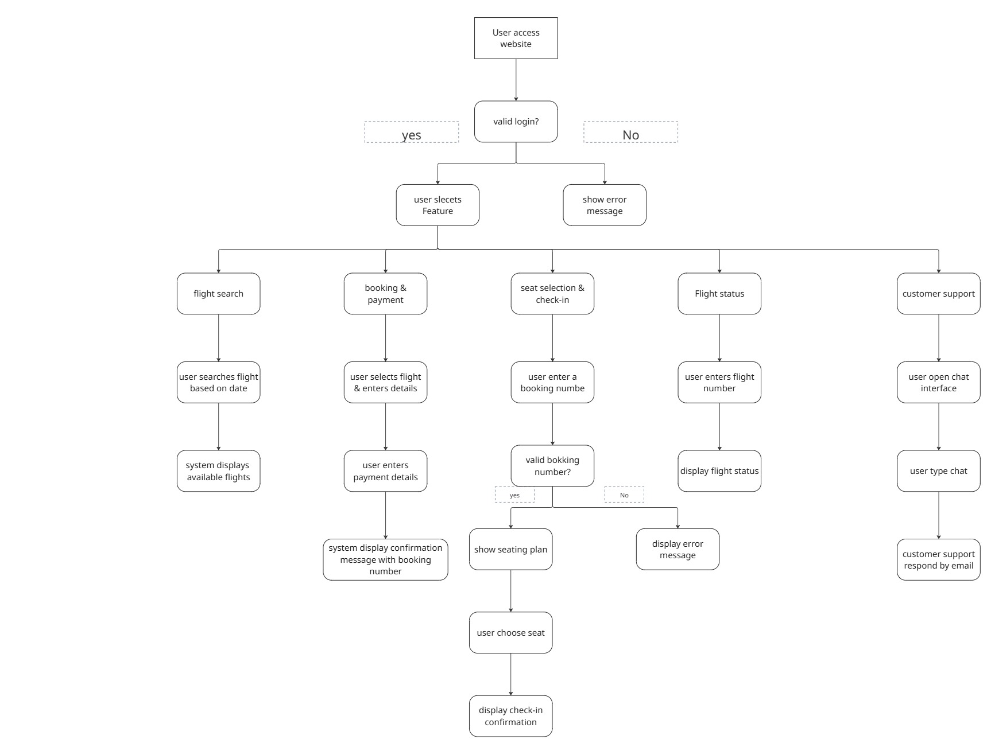
The following diagram shows the hierarchy of the functions and the validation process from the moment the user accesses the website till they complete their purpose.

The following diagram shows the hierarchy of the functions and the validation process from the moment the user accesses the website till they complete their purpose.

3.1

4.Develpoment
4.1. Main Page
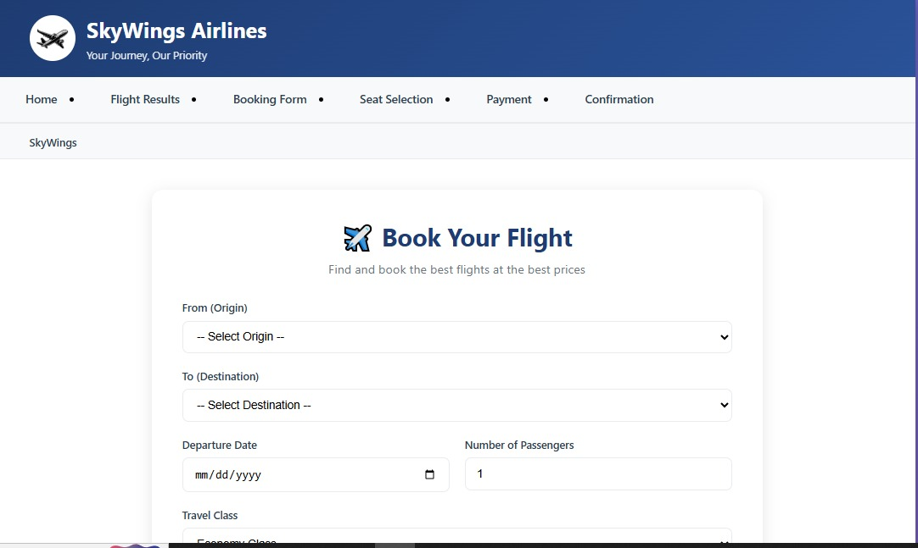
4.2. Available Flights
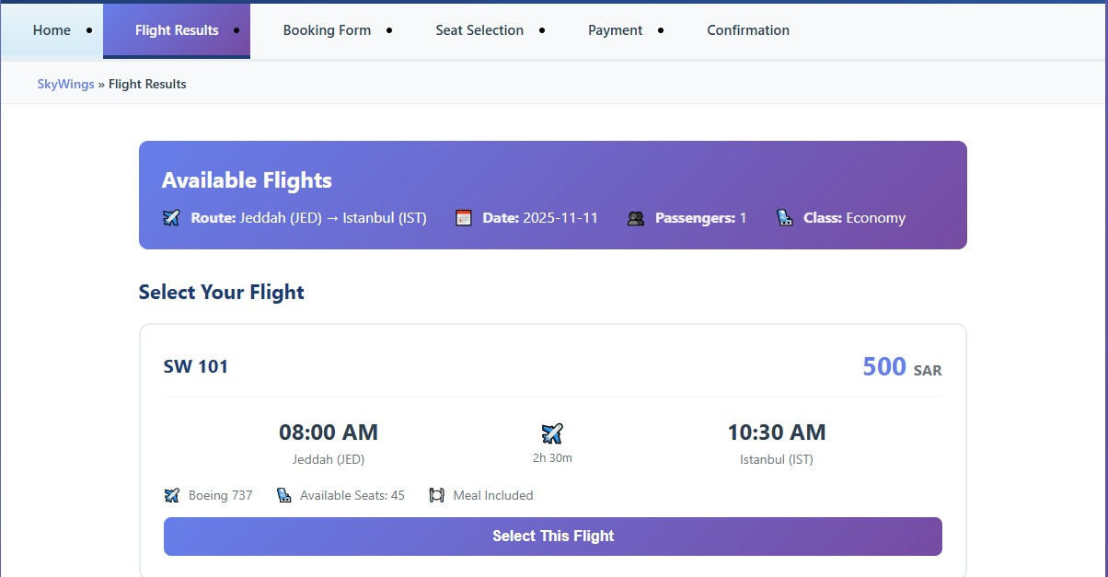

4.3. Select Seat
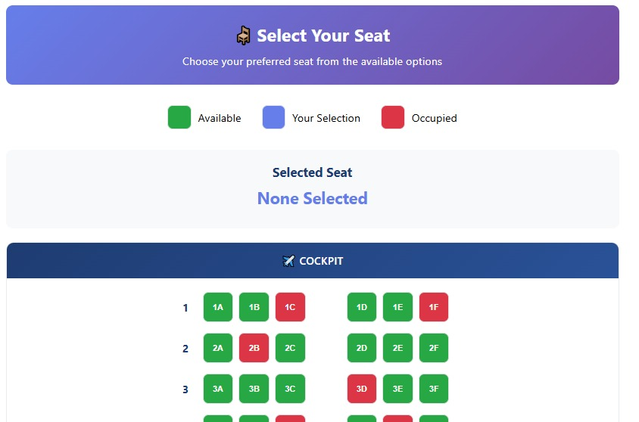
4.4. Flight Booking
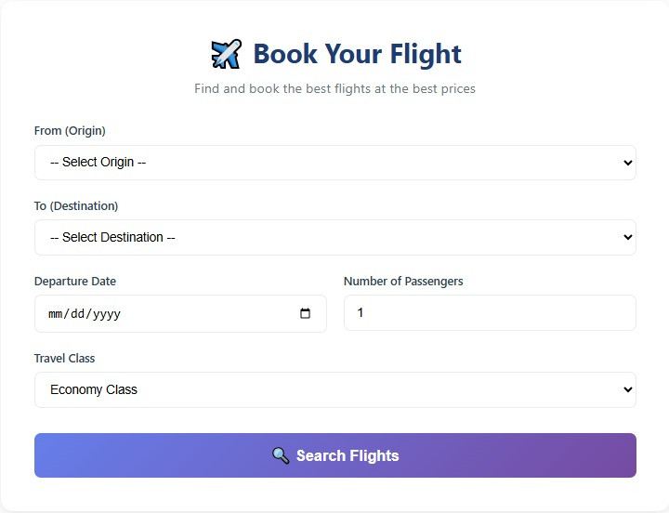

4.5. Passengers Detail
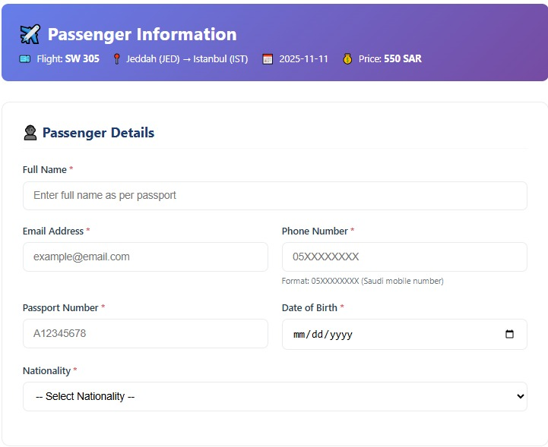
4.6. Fields Verification
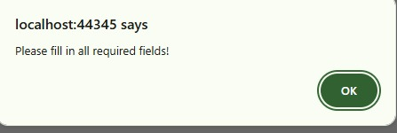.
4.7. Payment Methods

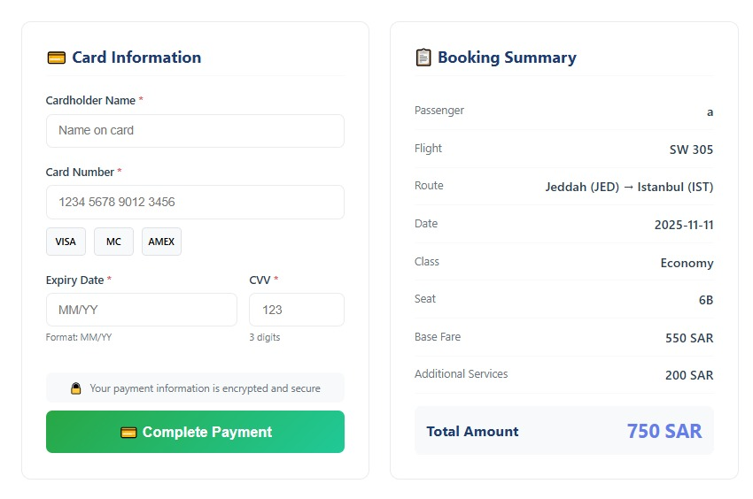

4.8. Terms and Conditions
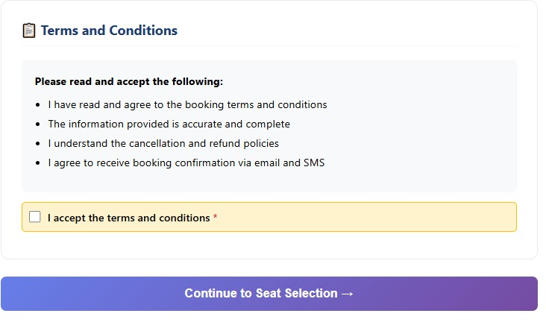

References
Abisoye, B. O., Umar, A., & Abisoye, O. A. (2017). Challenges of airline reservation system and possible solutions: A case study of Overland Airways. International Journal of Information Technology and Computer Science (IJITCS), 9(1), 34-45. https://doi.org/10.5815/ijitcs.2017.01.05
Aye, S. (2024). Online air ticket reservation system by using software agents. Computer University (Mandalay). https://meral.edu.mm/record/3992/files/55096.pdf meral.edu.mm+1
Selvaraj, P., Singh, R. K., Vaidya, H., Nayani, A. R., & Gupta, A. (2024). Implementation of an airline ticket booking system utilizing object-oriented programming and its techniques. International Journal of Intelligent Systems and Applications in Engineering, 12(11s), 694-705. https://www.ijisae.org/index.php/IJISAE/article/view/6856 ijisae.org+2ijisae.org+2
Qteishat, M. K., Alshibly, H. H., & Al-ma’aitah, M. A. (2014). The impact of e-ticketing technique on customer satisfaction: An empirical analysis. Journal of Information Systems and Technology Management, 11(3), 519–532. https://doi.org/10.4301/S1807-17752014000300001

